NO$GBA started as a Gameboy Advance debugger but was later released as a normal emulator(version 1.9). It is the first gameboy advance emulator to support multiplayer games on the same pc!
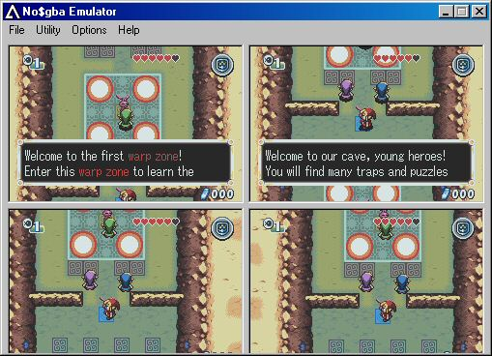

How to use multiplayer
- put the GBA BIOS file in the emulator's folder, and rename it to "gba.rom"
- run No$GBA.exe
- pick a GBA image (no ZIP)
- go to "Options" / "Emulation setup"
- increase the number of "Emulated Gameboys"
- in "Link Gamepaks", set "Gamepaks in all GBA"
- in "Reset/Startup Entrypoint", set "GBA BIOS (Nintendo logo")
- click OK, you should then see 2 GBA screens side by side
- right click on the left window, click on "Link" so that the window comes back to normal.
- then redo the right-click and click "Link" , and here we go, the 2nd gameboy does boot!
Please remember that the more Gameboy's you emulate the stonger the PC will have to be!

